Data Structure

A data structure in python can be defined as a structure which can holds related data. In other words we can say that data structure is a way of storing, organizing and fetching data in computer. There are four data structure in python :

1. List
2. Tuple
3. Dictionary
4. Set

In this chapter we will learn that how List can be implemented as STACK & QUEUES

STACK :

A stack is a linear data structure in python in which addition and deletion of elements can be done at one end only. A stack is known as LIFO (Last – In, First – Out) data structure in python. LIFO means the elements which are added in the last would be the first one to remove. Examples of stack are pile of books, pile of plates or stack of carom coins.

In above pile of rings the ring which we placed first is at the bottom and the ring which we placed in last is at the Top, So we can say that Stack is linear list implemented as LIFO.

Operations on Stack:

There are two main operations on Stack:

Addition of element on the Top of the Stack is called PUSH.

1. push (4)

2. push (7)

3. push ("a")

4. push ("Suman")

Above operations will form the stack as shown below :

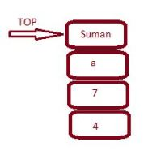

So you can observe that the element which we inserted first is coming at the bottom of the stack.

In the form of List the above stack can be shown as.

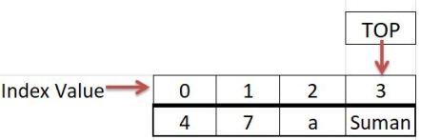Class 12 Computer Science Data Structure in Python Handout

Removal of elements from the top of the Stack is called POP.

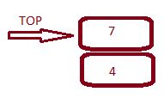

In the form of List the above stack will be represented as shown below

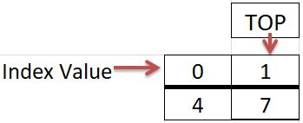

Working with Stack using List:

The implementation of stack using list is a simple process as there are inbuilt function which we used during working with stack. Basic operations that we should know are :

1. How to create an empty stack?
2. How to add elements to a stack?
3. How to delete / remove elements from the stack
4. How to traverse or displaying elements of stack?
5. How to check for empty stack?
6. Creating an Empty Stack : An empty stack can be created by using the following code

st = [ ] or st = list( ) #Here st is an empty stack

NOTE : Working with stack is similar to working with list (we can add element by append( ), we can remove element by pop( ) and we can display element by using index value)

2. Adding an element to a Stack : We can add element in a stack by using append( ) function as shown below

st.append(5)

Here element ‘5’ is added into a stack named ‘st’

NOTE : We can add element only at the end of the list as we are implementing list as stack.

3. Deleting elements from the stack : We can delete elements from the stack as shown below :

st.pop( )

NOTE : We can remove or delete element only from the end of the list as we are implementing list as stack.

4. Displaying all elements of the stack : We can display all elements in stack as shown below :

L = len(st)

for i in range(L-1, -1, -1) : #As we have to display elements in reverse order

print(st[i])

if (st == [ ]) :

print("stack is empty")

Queue :

A queue is a specialized data structure in which elements are added at one end called Rear and removed from other end called Front.

Operations on Queue :

A queue performs only two operations :

1. Insert : In this a new element is added at the end of list called Rear.
2. Delete : In this an element is to be deleted from one end called Front.

NOTE : Insertion and Deletion of elements takes place at different end. Addition at Rear and Deletion at Front

Queues in Daily Life :

We can see the formation of queues in our daily life like :

1. Outside the ATM
2. In Bank
3. Buying Ticket in Movie Hall